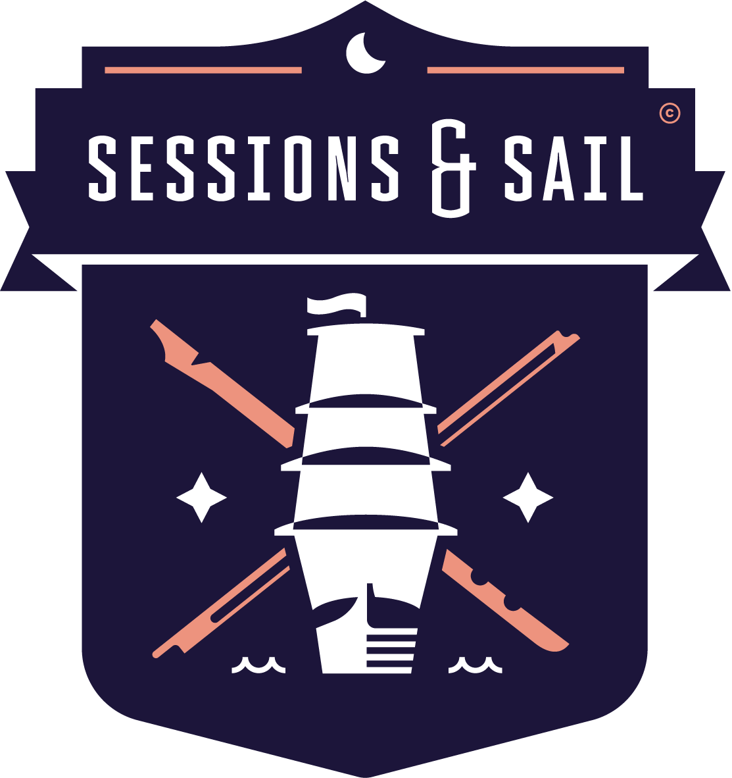
Sessions and Sail 2021 - Booking Form
Please fill out a separate form for each person joining the voyage.
Please complete and return by email to Barry@sessionsandsail.com
Or post to Sessions and Sail, Lingarth, Cullivoe, Yell, Shetland ZE2 9DD

1. Details.
Name | Title |  | First Name |  |  |  | Surname
Which trip?
Date of Birth
Address 1
Address 2
Town, County & Postcode
Telephone
Email address
Next of Kin | Name |  |  | Relationship |  |  |  | Telephone
NOK contact details
Travelling with
Dietary requirements
Other requirements
Medical conditions
Medication
Instrument, and to what level

Declaration

☐ I have read and accept the Terms and Conditions.
By checking this box, you confirm acceptance of the Terms and Conditions – Sessions and Sail. We cannot confirm any booking unless the box has been ticked.
☐ I am happy to or ☐ I would prefer not to appear in occasional pictures/videos taken during the voyage that Sessions and Sail may share online or for promotional purposes.
☐ I have or will have travel insurance in place.

A deposit of £250 will secure your booking; the full payment of £995 will be required to be in place 10 weeks before the start date.

You can make this payment to: Nisbet Marine Services, Account no 11530577 Sort Code 83-50-00

We look forward to having you along on your Sessions and Sail trip!

